VISVESVARAYA TECHNOLOGICAL UNIVERSITY
JNANA SANGAMA, BELAGAVI-590018


DEPARTMENT OF COMPUTER SCIENCE & ENGINEERING

2025-26

INTERNSHIP REPORT

ON

“DATA SCIENCE”

By

NAME
USN

CERTIFICATE

ACKNOWLEDGEMENT
We express our gratitude to our institution and management for providing us with good infrastructure, laboratory, facilities and inspiring staff, and whose gratitude was of immense help in the completion of this report successfully.
We are extremely great full in expressing our deep sense of gratitude to our honorable founder chairman NAME and administrative NAME for providing us a good infrastructure and facilities to carry out our Project work.
We are deeply indebted to NAME Principal, NAME , Bengaluru, who has been a constant source of enthusiastic inspiration to steer us forward.
We convey our profound gratitude to, NAME Head of the Department, Computer Science and Engineering, Dr. SMCE, for his unwavering support, insightful guidance and for making available the essential resources that greatly contributed to the successful execution of this project phase I to phase II at every stage.

we specially thank NAME , Asst. Professor, Department of Computer Science and Engineering who guided us with valuable suggestions in completing this project at every stage.
We would like to express our sincere thanks and heartfelt gratitude to our beloved Parents, Respected Professors both teaching and non-teaching staffs for their indispensable help at all times.

We are grateful for their co-operation during the period of our mini projectI would like to thank Mr. Mallikarjun Kumbar, Director ,Take it Smart (OPC) Pvt Ltd, for providing with technical support and knowledge.

CERTIFICATE

CERTIFICATE

CONTENTS

Chapter no. | Description | Page no.
1 | About the organization | 3
2 | Introduction to data science | 5
3 | Introduction to data | 11
4 | Introduction to Machine Learning | 16
5 | Introduction to Python | 20
6 | Project | 22
7 | Results and discussion | 28
 | Conclusion | 29
 | Attachments | 30

LIST OF FIGURES

Figure NO. | Description | Page no.
2.1 | Components of Data Science | 5
2.2 | Data Science Life Cycle | 8
4.4 | Machine Learning and Deep Learning Difference | 18
6.1 | Workflow Architecture | 23
7.1 | Interface | 28
7.2 | With Mask | 28
7.3 | Without Mask | 28
8.1 | Offer Letter | 30

LIST OF TABLES

Figure NO. | Description | Page no.
2.1 | Qualitative vs Quantitative data | 16
4.6 | Machine Learning v/s Deep Learning | 19

CHAPTER 1
ABOUT THE ORGANIZATION
ABOUT COMPANY

TAKE IT SMART (OPC) PVT LTD is an Indian based engineering and Software Company headquartered in Bangalore, Karnataka, India. It is both product and service oriented software company. All offices employ an experienced team of professionals, with an outstanding track record of handling complex web & Apps development projects.

1.1 HISTORY

The company was legally registered in the year 2021, but it made its humble beginning in the year 2018 with a team of Two members.

1.2 COMPANY STRATERGY

- Purpose: To be a leader in the software Industry by providing enhanced services, relationship and profitability.
- Mission: To build long term relationships with our customers and clients and provide exceptional customer services by pursuing business through innovation and advanced technology
- Vision: To provide quality services that exceeds the expectations of our esteemed customers.
- Core values:
- To incorporate good business practices in order to achieve customer satisfaction and treating the customers with respect and faith.
- To grow through creativity, invention and innovation.
- To integrate honesty, integrity and business ethics into all aspects of the business functioning.
Goals:
- To improve, grow and become more efficient in the field electronics engineering and software development and develop a strong base of key clients.
- To understand customer requirements and fulfill them.
- Increase the assets and investments of the organization to support the development of services and expansion of the organization.
- To increase the productivity and improve the customer service satisfaction.
- To do Innovations in Software field and provide quality services to deliver a range of products.

1.3 COMPANY SERVICES

TAKE IT SMART (OPC) PVT LTD has its own services such as,

- Embedded Applications development
- Web design and development
- IT Service
- Android app Development
- Web Bases Software Solutions
- Web Based Ads Mobile Based Services: Mobile Web Apps a. Android Apps b. Windows Apps c. IOS Apps d. Cross Plate forms Apps
- Native Apps
- Hybrid apps Get trained for industry requirements while you pursuing degree The Different verticals that we operate in are Internship & Software Training

1.4 DOMAINS

TAKE IT SMART (OPC) PVT LTD has working with several domains like

- IT
- Digital marketing
1.5 DEPARTMENTS

- Marketing: These are the main section of the market departments:
- Sales department is responsible for the sales and distribution of the products to the different regions.
- Promotion department decides on the type of promotion method for the products, arranges advertisements and the advertising media used.
- Distribution department distributes the products across the industries.
- Embedded System and Internet of Things (IOT) department.
- Machine learning and web development department
Business Address: Take It Smart (OPC) Pvt Ltd
14, SGN Arcade, 1st Floor, 2nd stage, 1st Main Rd,
RPC Layout, Hoshalli Extension, Stage 1,
Vijayanagar, Bengaluru, Karnataka 560040
Mobile: +91-8050104212
Email: info@takeitsmart.in
Website: www.takeitsmart.in

CHAPTER 2
INTRODUCTION TO DATA SCIENCE

2.1 DATA SCIENCE
Data science is a multidisciplinary field that uses statistical and computational methods to extract insights and knowledge from data. It involves a combination of skills and knowledge from various fields such as statistics, computer science, mathematics, and domain expertise. The process of data science involves several steps, including data collection, cleaning, exploration, analysis, and interpretation. These steps are often iterative, and the process may be refined based on the results obtained. Data science is used in a wide range of applications, including business, healthcare, social science, engineering, and many others. Some examples of data science applications include fraud detection, personalized marketing, medical diagnosis, predictive maintenance, and recommendation systems.
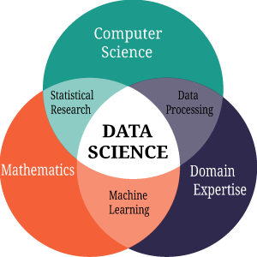

Fig. 1.1 Components of Data Science

What is Data Science?
Data Science is a multidisciplinary field that uses scientific methods, mathematical models, algorithms, and systematic processes to extract actionable insights and knowledge from structured and unstructured data.
At its core, Data Science is the intersection of:
- Mathematics and Statistics
- Computer Science and Programming
- Domain Expertise
- Definition (by IBM):
"Data science combines multi-disciplinary fields like statistics, data analysis, machine learning, and related methods to understand and analyse real-world phenomena with data."

Why is Data Science Important?
Data is being generated at an unprecedented rate—estimated at 328.77 million terabytes per day as of 2025. Companies, governments, and researchers rely on data to:

- Make better decisions
- Improve efficiency
- Predict future trends
- Personalize user experiences
- Detect fraud and anomalies
- Optimize business operations
Examples of real-world impact:
- Netflix uses data science for personalized recommendations.
- Amazon optimizes inventory and pricing through predictive analytics.
- Healthcare uses it for disease prediction and drug development.

Key Components of Data Science

- Data Collection – Gathering data from sensors, logs, surveys, web scraping, etc.
- Data Cleaning – Removing inconsistencies, missing values, duplicates
- Exploratory Data Analysis (EDA) – Understanding data patterns and summaries
- Modeling – Building predictive or classification models
- Deployment – Implementing the model in a real-world application
- Monitoring – Continuously checking the model's performance
2.1.3 Phases of the Data Science Process

1. Problem Definition
- Clearly identify the business or research problem.
- Convert business objectives into data science objectives.
- Example: “Predict customer churn” becomes a classification task.
2. Data Collection
- Acquire data from multiple sources such as databases, APIs, web scraping, sensors, or user surveys.
- Ensure data is relevant, accurate, and up-to-date.
- Common tools: SQL, Python requests, Scrapy.

3. Data Cleaning and Preparation
- Handle missing values, correct errors, remove duplicates, normalize or standardize data.
- Convert raw data into a usable format for analysis.
- Tools: Pandas, OpenRefine.
4. Exploratory Data Analysis (EDA)
- Analyze patterns, detect outliers, and understand variable relationships using summary statistics and visualizations.
- Techniques: histograms, box plots, correlation matrices.
- Tools: Matplotlib, Seaborn, Tableau.
5. Modeling
- Apply machine learning algorithms to build predictive or descriptive models.
- Split data into training and testing sets.
- Choose the right algorithm based on the problem type (e.g., regression, classification, clustering).
6. Evaluation
- Test model performance using metrics such as:
  - Accuracy, Precision, Recall, F1-Score (for classification)
  - RMSE, MAE (for regression)
- Fine-tune hyperparameters to optimize performance
7. Deployment
- Integrate the model into a production environment.
- Make predictions on live data via APIs, web apps, or embedded systems.
- Tools: Flask, FastAPI, AWS SageMaker.
8. Monitoring and Maintenance
- Continuously track model performance and retrain when necessary.
- Watch for model drift due to changing data trends.
- Tools: Prometheus, MLflow.

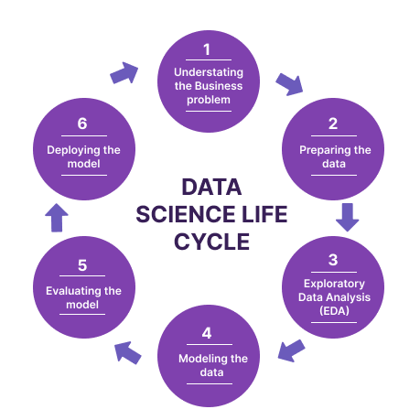
Fig 2.2 Data Science life cycle

Data is the backbone of data science. The quality, quantity, and variety of data significantly impact the outcome of any data science project. The process of gathering data is known as data collection, and it can come from various sources—structured or unstructured, internal or external, manual or automated.

2.2 Types of Data

1. Structured Data
- Data that resides in a fixed field within a record or file.
- Example: Excel spreadsheets, SQL databases.
- Easy to search, manage, and analyze.
2. Unstructured Data
- Information that doesn’t follow a specific format.
- Example: Emails, videos, images, social media posts, PDFs.
- Requires natural language processing (NLP), computer vision, et
3. Semi-structured Data
- Not in a strict structure, but contains tags or markers.
- Example: JSON, XML files, NoSQL databases.
Sources of Data
1. APIs (Application Programming Interfaces)
- Allow access to real-time and historical data.
- Examples:
  - Twitter API (for social media data)
  - OpenWeather API (for climate data)
  - Financial APIs like Alpha Vantage or Yahoo Finance

2. Web Scraping
- Automatic extraction of data from websites.
- Tools: BeautifulSoup, Scrapy, Selenium (Python libraries)
- Example: Scraping product details from Amazon or news articles from websites.
3. Surveys and Questionnaires
- Primary data collection technique.
- Useful for market research, academic studies, customer feedback.

4. Sensor Data / IoT Devices
- Includes data from smart devices, GPS, health trackers, etc.
- Real-time and high-frequency data.
5. Public Datasets
- Openly available datasets from governments, universities, and organizations.
- Examples:
  - Kaggle Datasets: https://www.kaggle.com/datasets
  - UCI Machine Learning Repository: https://archive.ics.uci.edu
  - Google Dataset Search: https://datasetsearch.research.google.com/
2.3 DATA SCIENCE SOFT SKILLS
- Communication
A data scientist should have a knack for linking business orientation with the scientific, analytical, and technical facets. They must communicate their findings to business users and decision-makers and explain what value these insights can bring to the business. This research must be conveyed effectively to both technical and non-technical audiences.
- Curiosity
Intellectual curiosity inspires data scientists to look for answers to address business crises. Professionals can go beyond initial assumptions and surface results. A data scientist must be curious enough to unlock solutions to known problems and uncover hidden, overlooked insights. As a result, they derive a higher quality of knowledge from their data sets.
- Business Acumen
Data scientists have to deal with a massive amount of knowledge. If they don’t translate it effectively, this priceless information goes down the drain because upper-level management never gets to use it to make business decisions. Data scientists need to appreciate current and upcoming industry trends and acquire basic business concepts and tools.

- Storytelling
Storytelling aids data scientists in conveying their results logically and clearly. It takes data visualization to another dimension, allowing decision-makers to see things from a new perspective. A compelling storytelling approach builds a strong data narrative where stakeholders attain a new sense of understanding about the data presented and use it to support their decisions going forward.
- Team Player
Data scientists don’t work inside a bubble, and they must recognize the importance of teamwork and collaborate effectively with others. They need to listen to other team members and use that input to their advantage.

2.4 IMPORTANCE OF LINEAR ALGEBRA IN DATA SCIENCE
Linear algebra in data science is important because of its crucial role in numerous sector components.
- It forms the backbone of machine learning algorithms, enabling operations like matrix multiplication, which are essential to model training and prediction.
- Linear algebra techniques facilitate dimensionality reduction, enhancing the performance of data processing and interpretation.
- Eigenvalues and eigenvectors help understand data records variability, influencing clustering and pattern recognition.
- Solving systems of equations is crucial for optimization tasks and parameter estimation.
- Furthermore, linear algebra supports image and signal processing strategies critical in data analysis.
- Proficiency in linear algebra empowers data scientists to successfully represent, control, and extract insights from data, in the end driving the development of accurate models and informed decision-making.
2.5 ALGORITHMS FOR DATA SCIENCE
- Problem Overview: The first step is identifying the issue data scientists seek to tackle. This could involve everything from identifying credit card theft to foreseeing client attrition.
- Data Gathering: After defining the issue, a data scientist must gather the information needed to address it. This might entail gathering information from many sources, including databases, APIs, and outside providers.
- Data Preprocessing: The data must be cleaned and transformed into a suitable format before data scientists can train machine learning models. This might involve scaling the data, addressing missing data, and encoding categorical variables.
- Model Selection: Data scientists must choose the best machine-learning approach to address the issue after preprocessing the data. Choosing from various methods, such as decision trees, logistic regression, or neural networks, may be required.
- Model Training: Once the best algorithm has been chosen, the model must be trained using the pre-processed data. This requires supplying the algorithm with the data and modifying the model’s parameters to enhance performance.

CHAPTER -3
INTRODUCTION TO DATA
3.1 WHAT IS DATA?
Data is different types of information usually formatted in a particular manner. All software is divided into two major categories: programs and data. We already know what data is now, and programs are collections of instructions used to manipulate data.
We use data science to make it easier to work with data. Data science is defined as a field that combines knowledge of mathematics, programming skills, domain expertise, scientific methods, algorithms, processes, and systems to extract actionable knowledge and insights from both structured and unstructured data, then apply the knowledge gleaned from that data to a wide range of uses and domains.
Computers represent data (e.g., text, images, sound, video), as binary values that employ two numbers: 1 and 0. The smallest unit of data is called a “bit,” and it represents a single value. Additionally, a byte is eight bits long. Memory and storage are measured in units such as megabytes, gigabytes, terabytes, petabytes, and exabytes. Data scientists keep coming up with newer, larger data measurements as the amount of data our society generates continues to grow.
Data can be stored in file formats using mainframe systems such as ISAM and VSAM, though there are other file formats for data conversion, processing, and storage, like comma-separated values. These data formats are currently used across a wide range of machine types, despite more structured-data-oriented approaches gaining a greater foothold in today’s IT world.
The field of data storage has seen greater specialization develop as the database, the database management system, and more recently, relational database technology, each made their debut and provided new ways to organize information.

3.2 DATA TYPES
- Structured data
Structured data adheres to a pre-defined data model. This model describes how data is recorded, and it defines the attributes and provides information about the data type (e.g. name, date, number) and restrictions on their values (e.g. number of characters). This level of organisation means that data can be entered, stored, queried, or analysed by machines. Structured data includes:
- Names
- Dates
- Phone numbers
- Currency or Prices
- Heights or Weights
- Latitude and Longitude
- Word count or File size of a document

- Unstructured and semi-structured data
- Images (human- and machine-generated)
- Video files
- Audio files
- Social-media posts
- Product reviews
- Messages sent by SMS or through online services

- Big data
- Volume: Data sets contain vast quantities of information that put high demands on systems used for storing, manipulating, and processing the information.
- Variety: It’s common for systems to process data from many sources, including emails, images, video, audio, readings from IoT devices, and even scanned PDF documents.
- Velocity: Vast quantities of data are being generated faster than ever, presenting challenges for analysts as more industries use this information. The ability to make instant decisions based on up-to-date information can make or break a business.

3.2 DATA HANDLING
- Data Collection and Acquisition
This step involves sourcing data from diverse channels such as databases, APIs, web scraping, sensor networks, and more. It’s imperative to identify relevant data sources and ensure data is collected in a consistent and structured manner.
- Data Cleaning and Preprocessing
Raw data is rarely clean and ready for analysis. Data cleaning is a crucial step to identify and rectify errors, inconsistencies, missing values, and outliers. Techniques such as imputation,
outlier detection, and data validation help refine the dataset. Data preprocessing involves tasks like standardization, normalization, and feature scaling, ensuring that data is prepared for downstream analysis.
- Exploratory Data Analysis (EDA)
Exploratory Data Analysis (EDA) is a cornerstone of data handling. EDA involves visualizing and summarizing data to gain insights and identify patterns. Techniques like histograms, scatter plots, box plots, and correlation matrices aid in understanding the distribution of variables and potential relationships. EDA helps data scientists make informed decisions about data transformations and feature engineering.

- Feature Engineering
Feature engineering is the art of creating new features from existing ones to enhance the performance of machine learning models. Techniques include dimensionality reduction, creating interaction terms, and generating domain-specific features. Thoughtful feature engineering can significantly impact model accuracy and interpretability.
- Data Integration
Data integration involves combining data from different sources to create a unified dataset. Techniques range from simple concatenation to more complex merging and joining operations. Ensuring data consistency and resolving conflicts are essential aspects of successful integration.
3.3 DATA MINING
Data mining is most commonly defined as the process of using computers and automation to search large sets of data for patterns and trends, turning those findings into business insights and predictions.
It is the process of extracting knowledge or insights from large amounts of data using various statistical and computational techniques. Data mining goes beyond the search process, as it uses data to evaluate future probabilities and develop actionable analyses. The data can be structures, semi-structures or unstructured, and can be stored in various forms such as databases, data warehouses, and data lakes.
3.3.1 PHASES OF DATA MINING
- Data Understanding
The data must be relevant to subject matter and usually comes from a variety of sources such as sales records, customer surveys, and geolocation data. This phase’s goal is to ensure the data correctly encompasses all necessary data sets to address the objective.
- Data Preparation
The most time-consuming phase, the preparation phase, consists of three steps: extraction, transformation, and loading — also referred to as ETL. First, data is extracted from various sources and deposited into a staging area. Next, during the transformation step: the data is cleaned, null sets are populated, duplicative data is removed, errors are resolved, and all data is allocated into tables. In the final step, loading, the formated data is loaded into the database for use.
- Modeling
Data modeling addresses the relevant data set and considers the best statistical and mathematical approach to answering the objective question(s). There are a variety of modeling techniques available, such as classification, clustering, and regression analysis (more on them later). It’s also not uncommon to use different models on the same data to address specific objectives.
- Evaluation
After the models are built and tested, it’s time to evaluate their efficiency in answering the question identified during the business understanding phase. This is a human-driven phase, as the individual running the project must determine whether the model output sufficiently meets their objectives. If not, a different model can be created, or different data can be prepared.

3.4 DATA ANALYTICS
Data analytics is the science of analyzing raw data to make conclusions about information. Many of the techniques and processes of data analytics have been automated into mechanical processes and algorithms that work over raw data for human consumption.
- Data analytics is the science of analyzing raw data to make conclusions about that information.
- Data analytics help a business optimize its performance, perform more efficiently, maximize profit, or make more strategically-guided decisions.
- The techniques and processes of data analytics have been automated into mechanical processes and algorithms that work over raw data for human consumption.
- Various approaches to data analytics include looking at what happened (descriptive analytics), why something happened (diagnostic analytics), what is going to happen (predictive analytics), or what should be done next (prescriptive analytics).

3.5 DATA ANALYSIS
Identify: The identification is the stage in which you establish the questions you will need to answer. For example, what is the customer's perception of our brand? Or what type of packaging is more engaging to our potential customers? Once the questions are outlined you are ready for the next step.

Collect: Here, you define which sources of data you will use and how you will use them. The collection of data can come in different forms such as internal or external sources, surveys, interviews, questionnaires, and focus groups, among others

Clean: Once you have the necessary data it is time to clean it and leave it ready for analysis. Not all the data you collect will be useful, when collecting big amounts of data in different formats it is very likely that you will find yourself with duplicate or badly formatted data. To avoid this, before you start working with your data you need to make sure to erase any white spaces, duplicate records, or formatting errors. This way you avoid hurting your analysis with bad-quality data.

Analyze: With the help of various techniques such as statistical analysis, regressions, neural networks, text analysis, and more, you can start analyzing and manipulating your data to extract relevant conclusions. At this stage, you find trends, correlations, variations, and patterns that can help you answer the questions you first thought of in the identify stage. Some of them include business intelligence and visualization software, predictive analytics, and data mining, among others.

Interpret: This stage is where the researcher comes up with courses of action based on the findings. For example, here you would understand if your clients prefer packaging that is red or green, plastic or paper, etc. Additionally, at this stage, you can also find some limitations and work on them.

3.5.1 DATA ANALYSIS STEPS
- The first step is to determine the data requirements or how the data is grouped. Data may be separated by age, demographic, income, or gender. Data values may be numerical or divided by category.
- The second step in data analytics is the process of collecting it. This can be done through a variety of sources such as computers, online sources, cameras, environmental sources, or through personnel.
- The data must be organized after it's collected so it can be analyzed. This may take place on a spreadsheet or other form of software that can take statistical data.
- The data is then cleaned up before analysis. It's scrubbed and checked to ensure that there's no duplication or error and that it is not incomplete. This step helps correct any errors before it goes on to a data analyst to be analyzed.

CHAPTER 4
INTRODUCTION TO MACHINE LEARNING
4.1 OVERVIEW

Machine learning (ML) is a branch of artificial intelligence (AI) that enables computers to “self-learn” from training data and improve over time, without being explicitly programmed. Machine learning algorithms are able to detect patterns in data and learn from them, in order to make their own predictions. In short, machine learning algorithms and models learn through experience. While artificial intelligence and machine learning are often used interchangeably, they are two different concepts. AI is the broader concept – machines making decisions, learning new skills, and solving problems in a similar way to humans – whereas machine learning is a subset of AI that enables intelligent systems to autonomously learn new things from data

4.2 QUALITATIVE AND QUANTITATIVE DATA

Qualitative Data | Quantitative Data
1. Qualitative data uses methods like interviews, participant observation, focus on a grouping to gain collective information. | 1. Quantitative data uses methods as questionnaires, surveys, and structural observations to gain collective information.
2. Data format used in it is textual.  Datasheets are contained of audio or video recordings and notes. | 2. Data format used in it is numerical. Datasheets are obtained in the form of numerical values.
3. Qualitative data talks about the experience or quality and explains the questions like ‘why’ and ‘how’ | 3. Quantitative data talks about the quantity and explains the questions like ‘how much’, ‘how many .
4. The data is analyzed by grouping it into different categories. | 4. The data is analyzed by statistical methods.
5.Qualitative data are subjective and can be further open for interpretation. | 5. Quantitative data are fixed and universal.
Table. 4.1 Qualitative vs Quantitative data

Types of Machine Learning
1. Supervised Learning
Definition: The model is trained on a labeled dataset (input-output pairs).
Examples:
  - Retail sales and profit prediction
  - Telecom churn prediction
  - Student performance analysis (EDA + prediction)

Common Algorithms:
  - Linear Regression
  - Decision Trees
  - Random Forest
  - Support Vector Machines (SVM)
Use Case: Predicting sales, profit, or customer churn.
2. Unsupervised Learning
Definition: The model works on unlabeled data and finds patterns or structure.
Examples:
  - Customer purchasing behavior analysis
Common Algorithms:
  - K-Means Clustering
  - Hierarchical Clustering
  - PCA (Principal Component Analysis)
Use Case: Customer segmentation and behavior analysis.
3. Computer Vision (Deep Learning)
Definition: Enables machines to interpret and process visual data like images and videos.
Examples:
  - Potato plant disease detection
  - Face mask detection
Common Algorithms / Models:
  - Convolutional Neural Networks (CNN)
  - MobileNetV2
  - Image Classification Models
Use Case: Disease detection in plants, safety compliance (mask detection).
4. Data Analysis & Exploratory Data Analysis (EDA)
Definition: Process of analyzing datasets to summarize their main characteristics.
Examples:
  - Student performance EDA
  - Retail data insights

Common Techniques:
  - Data Cleaning
  - Visualization (Matplotlib, Seaborn)
  - Statistical Analysis
- Natural Language Processing (NLP)
Definition: Deals with understanding and processing human language.
Examples:
  - Sentiment analysis
  - Text classification
  - General NLP tasks
Common Techniques:
  - Tokenization
  - TF-IDF
  - Word Embeddings
Use Case: Chatbots, text classification, sentiment detection.

Deep learning, on the other hand, is a subset of machine learning that uses neural networks with multiple layers to analyze complex patterns and relationships in data. It is inspired by the structure and function of the human brain and has been successful in a variety of tasks, such as computer vision, natural language processing, and speech recognition.
Deep learning models are trained using large amounts of data and algorithms that are able to learn and improve over time, becoming more accurate as they process more data..

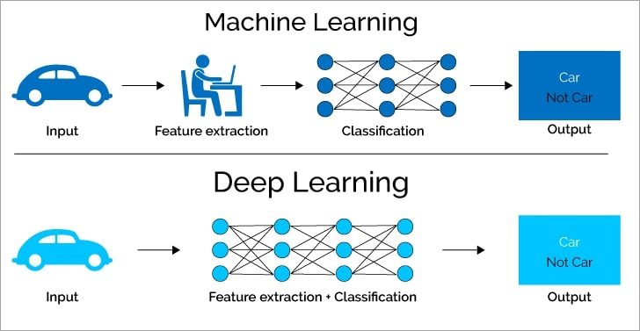
Fig 4.1 Machine learning and Deep learning

Types of Deep Learning
Deep learning encompasses various architectures, each suited to different types of tasks:
- Convolutional Neural Networks (CNNs): Primarily used for image processing tasks, CNNs are designed to automatically and adaptively learn spatial hierarchies of features through convolutional layers.
- Recurrent Neural Networks (RNNs): Ideal for sequential data, such as time series or natural language, RNNs have loops that allow information to persist, making them effective for tasks like speech recognition and language modeling.
- Long Short-Term Memory Networks (LSTMs): A type of RNN that addresses the vanishing gradient problem, LSTMs are used for complex sequences, including text and speech.
- Generative Adversarial Networks (GANs): These consist of two neural networks (generator and discriminator) that compete against each other, leading to the creation of high-quality synthetic data, such as images.
- Transformers: A more recent architecture designed for handling long-range dependencies in data, transformers are the backbone of models like GPT and BERT, used extensively in natural language processing.
Future of Machine Learning and Deep Learning
Both machine learning and deep learning have the potential to transform a wide range of industries, including healthcare, finance, retail, and transportation, by providing insights and automating decision-making processes.
- Machine Learning: Machine learning is a subset, an application of Artificial Intelligence (AI) that offers the ability of the system to learn and improve from experience without being programmed to that level. Machine Learning uses data to train and find accurate results. Machine learning focuses on the development of a computer program that accesses the data and uses it to learn from itself.
- Deep Learning: Deep Learning is a subset of Machine Learning where the artificial neural network and the recurrent neural network come in relation. The algorithms are created exactly just like machine learning but it consists of many more levels of algorithms. All these networks of the algorithm are together called the artificial neural network.

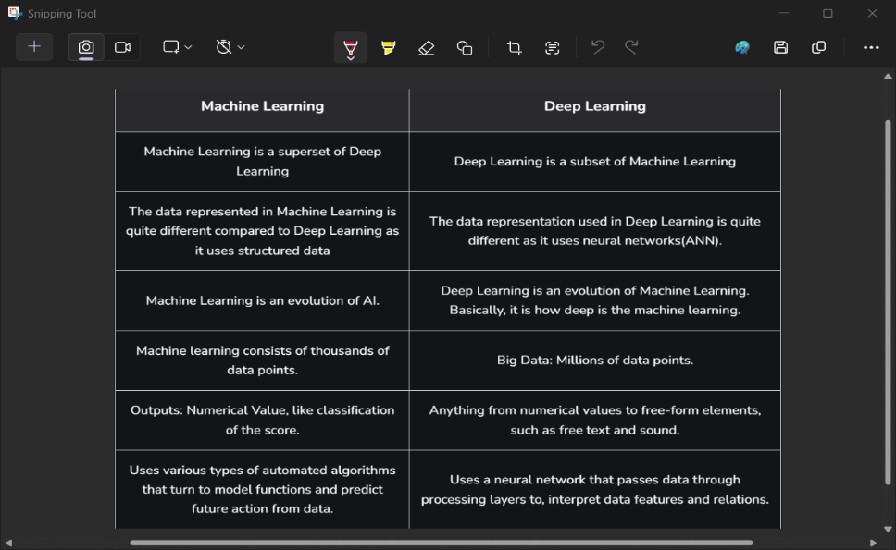

Table 4.1 Machine Learning vs Deep Learning

CHAPTER 5
INTRODUCTION TO PYTHON
Python is a widely used general-purpose, high level programming language. It was created by Guido van Rossum in 1991 and further developed by the Python Software Foundation. It was designed with an emphasis on code readability, and its syntax allows programmers to express their concepts in fewer lines of code. Python is a programming language that lets you work quickly and integrate systems more efficiently. There are two major Python versions: Python 2 and Python 3. Both are quite different.

5.1 PYTHON DATA TYPES
Python Data types are the classification or categorization of data items. It represents the kind of value that tells what operations can be performed on a particular data. Since everything is an object in Python programming, Python data types are classes and variables are instances (objects) of these classes. The following are the standard or built-in data types in Python:
- Numeric Data Type
The numeric data type in Python represents the data that has a numeric value. A numeric value can be an integer, a floating number, or even a complex number. These values are defined as Python int, Python float, and Python complex classes in Python.
- Sequence Data Type
The sequence Data Type in Python is the ordered collection of similar or different Python data types. Sequences allow storing of multiple values in an organized and efficient fashion. There are several sequence data types of Python:
- Python String
- Python List
- Python Tuple

- Boolean Data Type
Python Data type with one of the two built-in values, True or False. Boolean objects that are equal to True are truthy (true), and those equal to False are falsy (false). However nonBoolean
objects can be evaluated in a Boolean context as well and determined to be true or false. It is denoted by the class bool.

- Set Data Type
In Python Data Types, a Set is an unordered collection of data types that is iterable, mutable, and has no duplicate elements. The order of elements in a set is undefined though it may consist of various elements.

- Dictionary Data Type
A dictionary in Python is an unordered collection of data values, used to store data values like a map, unlike other Python Data Types that hold only a single value as an element, a Dictionary holds a key: value pair. Key-value is provided in the dictionary to make it more optimized. Each key-value pair in a Dictionary is separated by a colon: , whereas each key is separated by a ‘comma’.

5.2 PYTHON DATA ANALYTICS
Data Analysis is the technique of collecting, transforming, and organizing data to make future predictions and informed data-driven decisions. It also helps to find possible solutions for a business problem. There are six steps for Data Analysis. They are:
- Ask or Specify Data Requirements
- Prepare or Collect Data
- Clean and Process
- Analyze
- Share
- Act or Report Python Functions

5.3 PYTHON FUNCTIONS
Python Functions is a block of statements that return the specific task. The idea is to put some commonly or repeatedly done tasks together and make a function so that instead of writing the same code again and again for different inputs, we can do the function calls to reuse code contained in it over and over again.
Here are simple rules to define a function in Python:
- Function blocks begin with the keyword def followed by the function name and parentheses ( ).
- Any input parameters or arguments should be placed within these parentheses.
- The first statement of a function can be an optional statement - the documentation string of the function or docstring.
- The code block within every function starts with a colon (:) and is indented.
- The statement return [expression] exits a function, optionally passing back an expression to the caller.
- A return statement with no arguments is the same as return none.

5.4 PYTHON MODULE
A Python module is a file containing Python definitions and statements. A module can define functions, classes, and variables. A module can also include runnable code. Grouping related code into a module makes the code easier to understand and use.
- Create a Python Module
To create a Python module, write the desired code and save that in a file with .py extension.
def greeting(name):
print(“Hello, “ + name)
- Use a Module
Now we can use the module we just created, by using the import statement:
import mymodule
mymodule.greeting(“Jonathan”)
- Variables in Module
The module can contain functions, as already described, but also variables of all types (arrays, dictionaries, objects etc):

CHAPTER 6:
PROJECT
6.1 Introduction
The Customer Churn Prediction System is a machine learning-based application designed to predict whether a customer is likely to leave a service or not. This project uses classification algorithms to analyze customer data and identify patterns that indicate churn behavior.The system is built using the Random Forest Classifier, a powerful ensemble learning algorithm known for its accuracy and robustness. The model processes historical customer data and predicts churn based on various features.This project is highly useful in industries such as telecom, banking, and e-commerce, where retaining customers is critical for business growth.
6.2 Problem statement
Customer churn is a major challenge for businesses, as losing customers directly impacts revenue and growth. Identifying customers who are likely to churn in advance allows companies to take preventive actions.However, manual analysis of customer data is difficult due to large volumes and complex patterns. There is a need for an automated system that can efficiently predict churn with high accuracy.This project aims to build a machine learning model that predicts whether a customer will churn or not using historical data.
6.3 Objectives of the Project
The objectives of this project are:
To develop a customer churn prediction system
To perform data cleaning and preprocessing
To encode categorical data into numerical form
To apply machine learning algorithms for classification
To evaluate model performance using accuracy metrics
To save the trained model for future predictions
Additionally, the project aims to create a scalable solution that can be integrated into real-time business systems.

6.4 System Architecture
The system consists of the following stages:
Input Layer: Customer dataset (CSV file)
Data Preprocessing: Cleaning, handling missing values, encoding
Feature Engineering: Splitting features and target variable
Model Training: Random Forest Classifier
Evaluation Layer: Accuracy calculation
Output Layer: Churn prediction result

6.5 Tools and technologies
6.5.1 Pandas
Used for data loading and manipulation
Handles missing values and duplicates
Works with structured datasets

6.5.2 NumPy
Supports numerical computations
Used for array operations
Improves performance of data processing

6.5.3 Scikit-learn
Provides machine learning algorithms
Used for:
Train-test splitting
Label encoding
Feature scaling
Model training and evaluation

6.5.4 Joblib
Used to save trained models
Enables reuse without retraining

6.6 Data Understanding
Dataset Description
Contains customer-related features
Includes target variable: Churn (Yes/No or 1/0)

Data Exploration
Checked for missing values
Identified categorical and numerical columns
Observed dataset structure

Observations
Presence of missing values
Categorical features need encoding
Data requires normalization

6.7 Data Preprocessing
Steps Involved
1. Removing Duplicates
Duplicate rows are removed to ensure data quality
2. Handling Missing Values
Categorical columns → filled with mode
Numerical columns → filled with mean
3. Encoding Categorical Data
Label Encoding is applied
Converts text data into numerical form
4. Feature and Target Split
Features (X): Input variables
Target (y): Churn column
5. Train-Test Split
Data split into:
Training set (80%)
Testing set (20%)
6. Feature Scaling
StandardScaler is applied
Ensures all features are on the same scale

6.8 Model Building
Algorithm Used: Random Forest Classifier
Ensemble learning method
Combines multiple decision trees
Improves accuracy and reduces overfitting

Model Design
Input: Scaled feature data
Output: Binary classification (Churn / No Churn)

Why Random Forest?
High accuracy
Handles large datasets
Works well with both categorical and numerical data

6.9 Model Training
Training Process
Model trained using training dataset
Learns patterns from customer data
Key Aspects
Uses multiple decision trees
Aggregates predictions for final output

6.10 Model Evaluation
Metric Used:
Accuracy
Measures correctness of predictions
Formula:
Accuracy = (Correct Predictions / Total Predictions)
Analysis
High accuracy indicates good model performance
Helps evaluate prediction capability

6.11 Model Prediction
Steps
Load new customer data
Apply preprocessing (same as training)
Use trained model to predict
Output
Churn (1) → Customer likely to leave
No Churn (0) → Customer likely to stay

6.12 Model Deployment
Model saved using Joblib
model.pkl → trained model
scaler.pkl → scaling object
Advantages
No need to retrain model
Can be used in web applications
Faster predictions

6.13 Limitations of the System
- Accuracy depends on dataset quality
- Cannot handle unseen patterns effectively
- Requires proper preprocessing for new data
6.14 Future Enhancements
- Use advanced algorithms like XGBoost
- Deploy using web frameworks (Flask/Streamlit)
- Improve feature engineering
- Add real-time prediction system
- Use deep learning models for better accuracy

CHAPTER 7

7.1 CODE
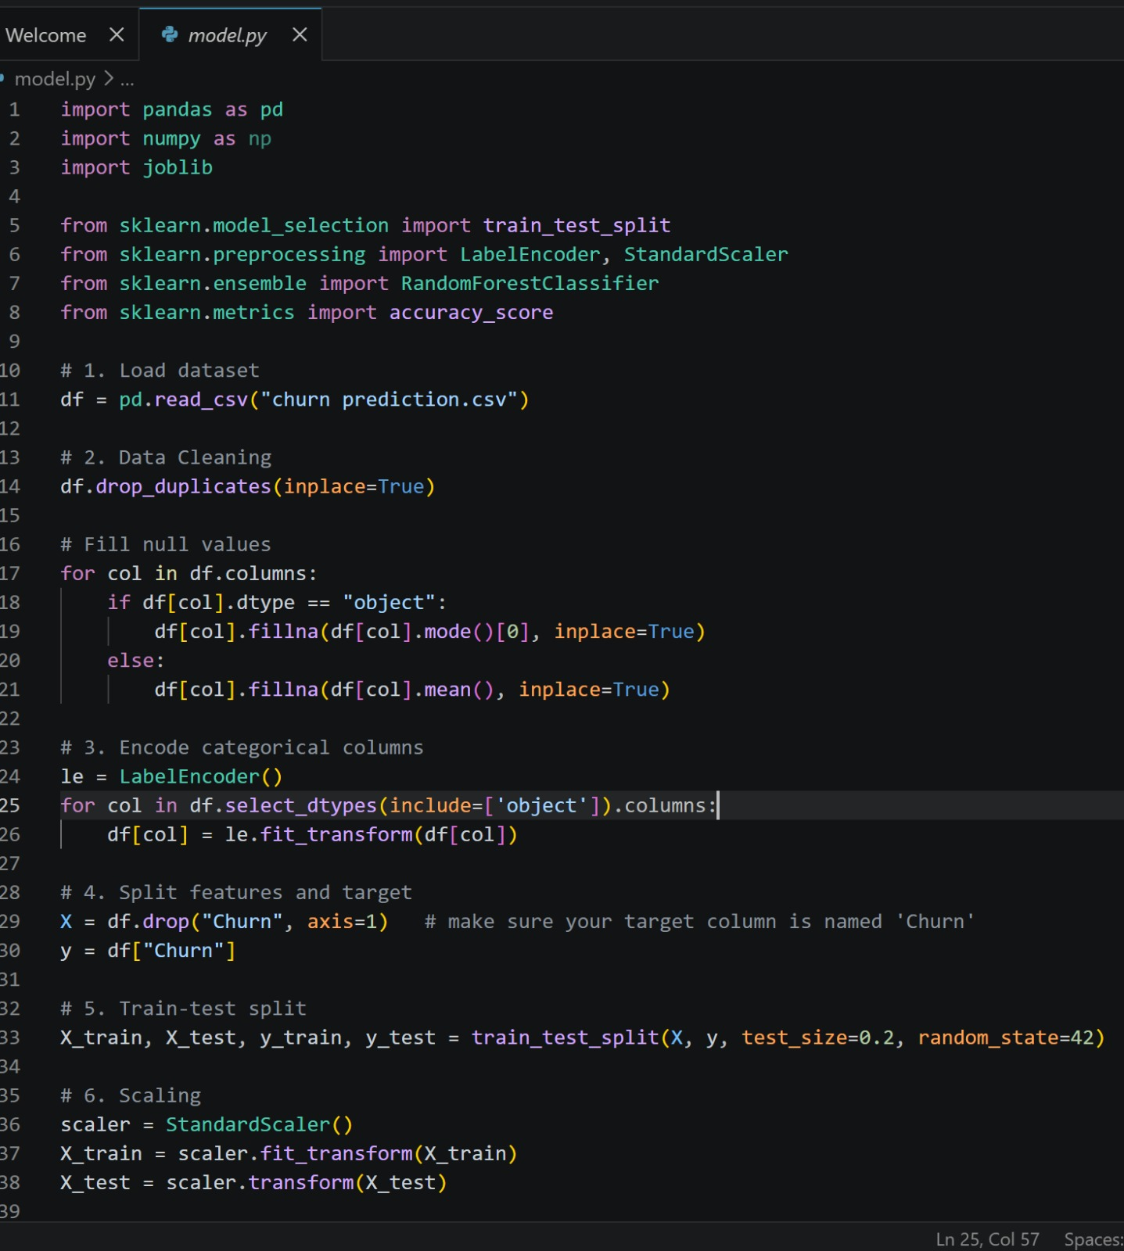

7.2 RESULTS AND DISCUSSION

- Model successfully predicts customer churn
- Achieved good accuracy on test data
- Efficient in handling structured datasets
- Suitable for business decision-making

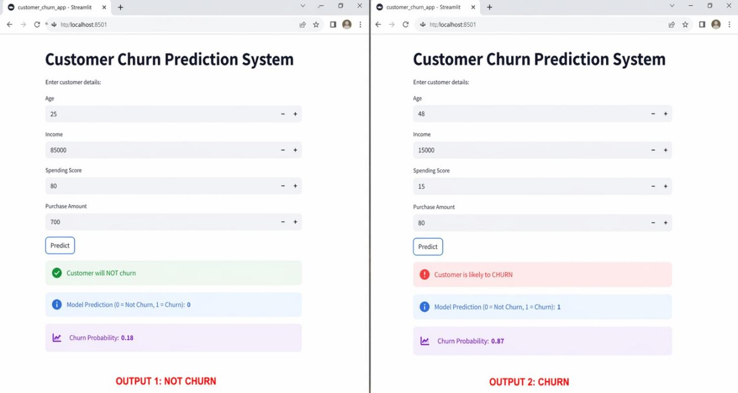

CONCLUSION

The internship at Take It Smart Pvt. Ltd. provided a valuable learning experience in the field of Data Science. It helped me understand the practical aspects of data analysis, machine learning, and the workflow involved in solving real-world data-driven problems. The exposure to industry-relevant concepts improved my overall technical knowledge and analytical thinking.

During the internship, I gained knowledge of core Data Science concepts such as data preprocessing, exploratory data analysis, and machine learning techniques. I also understood the importance of working with structured datasets and extracting meaningful insights from data. Learning about model building and evaluation further strengthened my understanding of predictive analytics and decision-making processes.

The internship also helped me become familiar with development tools such as Git and Visual Studio Code. These tools improved my coding efficiency and introduced me to version control practices. Additionally, it enhanced my problem-solving abilities, logical reasoning, and data interpretation skills in analytical scenarios.
The Customer Churn Prediction project provided valuable insights into machine learning and data preprocessing techniques. It helped in understanding how to handle real-world datasets, clean data, and build predictive models.
Through this project, knowledge of classification algorithms, especially Random Forest, was strengthened. The use of tools like Pandas, NumPy, and Scikit-learn improved practical implementation skills.The project demonstrates how machine learning can be applied to solve real-world business problems such as customer retention. Overall, it enhanced analytical thinking, problem-solving skills, and understanding of predictive modeling.

ATTACHMENTS

CERTIFICATE

Figure 9.1:Offer letter

